Report
Developing a Class-Based Ride Sharing System

This assignment focuses on the design and implementation of a Ride Sharing System using two programming languages, Smalltalk and C++, in order to demonstrate key Object-Oriented Programming (OOP) principles, including encapsulation, inheritance, and polymorphism. The system models a simplified version of a ride-sharing platform consisting of core entities such as Ride, StandardRide, PremiumRide, Driver, and Rider. The base class Ride contains shared attributes such as rideID, pickupLocation, dropoffLocation, and distance, which are used across all ride types. The derived classes StandardRide and PremiumRide extend the base class and override the fare calculation method to implement different pricing strategies. The Driver and Rider classes manage ride assignments and ride requests, respectively, allowing interaction between users and ride objects in a structured and modular way.
Encapsulation is implemented in both Smalltalk and C++ by restricting direct access to internal data and exposing controlled interfaces through methods. In C++, encapsulation is enforced using private access modifiers, ensuring that sensitive data such as driverID, name, and assignedRides cannot be directly accessed from outside the class. Instead, public methods such as addRide() are used to modify or retrieve data safely. For example, in the Driver class:
private:
int driverID;
string name;
vector<Ride*> assignedRides;
public:
void addRide(Ride* ride) {
assignedRides.push_back(ride);
}

Similarly, in Smalltalk, instance variables are encapsulated within classes, and interaction with data occurs only through methods. For example, rides are added to a driver using a controlled method:
Driver >> addRide: ride
assignedRides add: ride.

This ensures that internal data structures remain protected and are only modified through defined behaviors.
Inheritance is demonstrated through the hierarchical relationship between the Ride base class and its derived classes StandardRide and PremiumRide. The base class contains shared properties and methods, while subclasses extend and customize functionality. In C++, inheritance is explicitly defined using the class extension syntax:
class StandardRide : public Ride {
public:
double fare() const override {
return distance * 2.0;
}};

In Smalltalk, inheritance is implemented using subclassing, where both StandardRide and PremiumRide inherit from Ride and override the fare method:
PremiumRide >> fare
^ distance * 4.0.

this design promotes code reuse while allowing specialized behavior for different ride types.
Polymorphism is a central feature of this system and is demonstrated through method overriding and dynamic method dispatch. In both languages, the same method call results in different behavior depending on the object type. In C++, polymorphism is achieved using virtual functions in the base class Ride:
virtual double fare() const {
return distance * 1.5;}

When stored in a collection of base-class pointers, each object calls its own overridden version of the fare method at runtime:
for (Ride* ride : rides) {
cout << ride->fare() << endl; }

In Smalltalk, polymorphism is inherently supported through message passing. The same message fare is sent to different objects, and the correct method is resolved dynamically:
rides do: [ :r |
Transcript show: r fare; cr. ].

This demonstrates true runtime polymorphism without requiring explicit type declarations.
There are important conceptual differences between Smalltalk and C++ in their implementation of OOP. Smalltalk is a pure object-oriented language where everything is treated as an object and method dispatch occurs dynamically by default. This makes polymorphism and inheritance more natural and flexible. In contrast, C++ is a hybrid language that supports both procedural and object-oriented paradigms. It requires explicit use of keywords such as virtual and override to enable runtime polymorphism and uses static typing, which provides more control but requires additional syntax.
In conclusion, this project successfully demonstrates the application of encapsulation, inheritance, and polymorphism in a Ride Sharing System implemented in both Smalltalk and C++. The use of two different programming languages highlights different approaches to object-oriented design while reinforcing the same fundamental principles. The system effectively models real-world relationships between rides, drivers, and riders, and demonstrates how OOP concepts can be used to build modular, reusable, and scalable software systems.

Screenshots
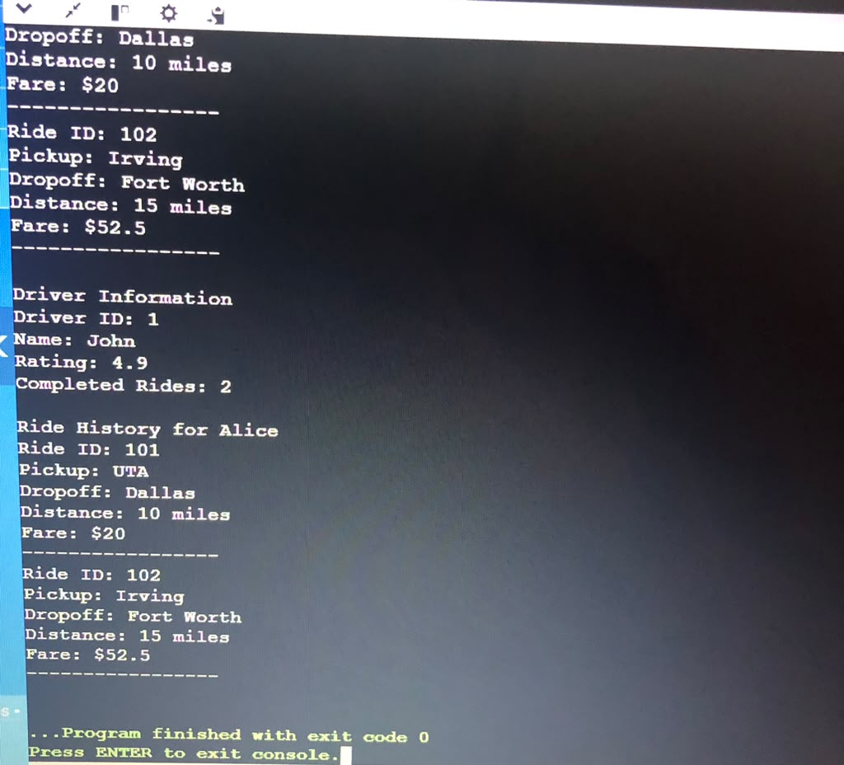

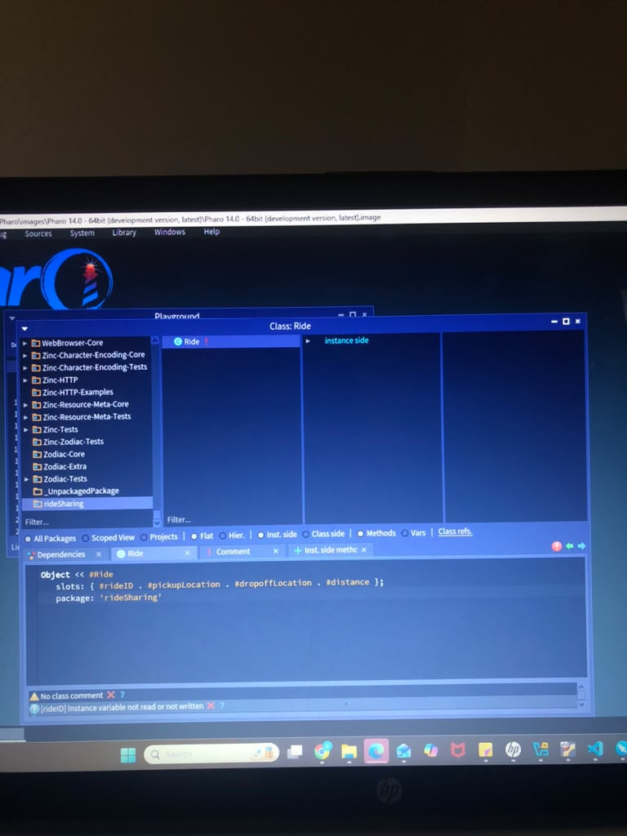

Github Link : https://github.com/umamaz/Ride-Sharing-
References
Stroustrup, B. (2013). The C++ programming language (4th ed.). Addison-Wesley Professional.
Goldberg, A., & Robson, D. (1983). Smalltalk-80: The language and its implementation. Addison-Wesley.
Gamma, E., Helm, R., Johnson, R., & Vlissides, J. (1994). Design patterns: Elements of reusable object-oriented software. Addison-Wesley.

